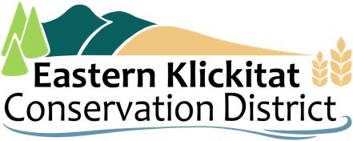
Agenda – EKCD Business Meeting
  - April 21, 2026 | 7:00 PM | Bickleton Fire Hall
Time | Topic | Description / Details | Lead
7:00 | Call to Order |  | Jason Blain
7:03 | Approve Agenda |  | Jason Blain
7:05 | Public Comment |  | Jason Blain
7:10 | NRCS Report |  | Written Report
7:45 | District Business | - Presentation by Rainmaker  - Prescribed burn waiver  - Annual plan of work  - Revision to bidding policy  - NRCS MOU discussion  - Executive Session RCW 42.30.110(1)(i) | Loren Meagher
9:00 | Adjourn |  | Jason Blain

